

ST10051335-CLDV6211 part 1

.



April 7, 2025

st10051335

Tyrique Haniff

<https://github.com/VCDN-2025/cldv6211-poe-part-1-st10051335>

A

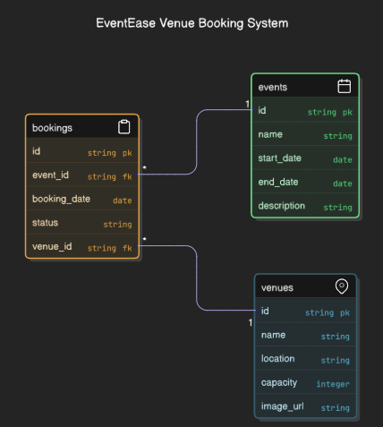

B

# D. Cloud Setup Basics

Alternatives during deployment of software solutions include purchasing or leasing hardware for on-site installation or cloud-based deployment. The alternatives stand to offer various benefits and different dealbreakers in terms of security, deployment times, and resources. In an on-premises deployment, the business is responsible for maintaining physical servers, updates of applications, and verification of security. Such setups generally require a fair amount of initial capital investment for the purchase of hardware and retention of IT staff. Security is customizable and, while such customization allows it to be tailored to the needs of a specific company, it can also become excessively unwieldy and vulnerable to misconfiguration by a slightly fatigued human resource. Deployment can be agonizingly slow, with the infrastructure having to be setup physically and configured before applications will work. Resource management is inflexible; scaling the application for more users or more data implies buying and installing new hardware, which are lengthy and expensive undertakings.

In contrast, cloud deployment using products such as Microsoft Azure provides a more flexible alternative with less overhead for the contractors. Built-in security features, automated updates, and compliance certifications mean much less pressure on developers. With services like Azure App Service, an application can be deployed in a few minutes, and it can automatically scale up or down depending on the demand. For example, EventEase can rapidly scale its platform to accommodate seasonal spikes in bookings devoid of any changes in hardware.

The three main cloud service models are classified as Infrastructure as a Service (IaaS), Platform as a Service (PaaS), and Software as a Service (SaaS).

IaaS allows for the purchase of raw computing resources through the Internet, such as virtual machines that can be used for storage. It provides the maximum control but requires more setup and maintenance from the user. IaaS might not be the best solution for any small to medium-scale enterprise, more so for EventEase.

SaaS offers fully-developed software on the Internet (for example, Microsoft 365 for Office, Google Workspace). While featuring a ship-load of ease for deployment, SaaS lacks the flexibility to be able to build a custom venue booking platform.

PaaS sits between the two in flexibility and control. PaaS provides a complete development and deployment environment without the overhead of managing the underlying hardware and operating system. As Azure App Service and Azure SQL Database allow EventEase developers to build and enhance the application while Azure manages the hosting, scaling, and maintenance of the app.

Hence, PaaS will be the most suitable model for EventEase. This makes it comparatively swift in implementation, cost-efficient, and scale-friendly to design and maintain a custom venue booking solution in the cloud.

# References

Hughes, A. (2018b). *Blog: On Premise vs. Cloud: Key Differences, Benefits and Risks | Cleo*. [online] Cleo. Available at: <https://www.cleo.com/blog/knowledge-base-on-premise-vs-cloud> [Accessed 7 Apr. 2025].

Flower, Z. (2021b). *On premises vs. cloud: The major similarities and differences*. [online] SearchCloudComputing. Available at: <https://www.techtarget.com/searchcloudcomputing/tip/Evaluate-on-premises-vs-cloud-computing-pros-and-cons> [Accessed 7 Apr. 2025].

Dinh, C. (2024b). *A Comprehensive Guide To On-Premise Deployment For Businesses | Relia Software*. [online] Reliasoftware.com. Available at: <https://reliasoftware.com/blog/on-premise-deployment> [Accessed 7 Apr. 2025].

IBM (2021). *IaaS, PaaS and SaaS*. [online] Ibm.com. Available at: <https://www.ibm.com/think/topics/iaas-paas-saas> [Accessed 7 Apr. 2025].